Assignment 2: Advanced CSS Layout with Flexbox and Grid

Course: Web Development

Group: SE-2404

University: Astana IT University

Date: 27.09.025

# Team Information

|  |  |
| --- | --- |
| **Field** | **Information** |
| Team Name | Coffee PO |
| Group | SE-2404 |
| Team Members | Balgyn Yermakhanbet, Ayana Markhabat |
| University | Astana IT University |
|  |  |
|  |  |

Assignment Objective

The objective of this assignment was to enhance our existing coffee shop website by implementing advanced CSS layout techniques using Flexbox and Grid systems. The goal was to create a modern, responsive, and well-structured website that demonstrates proficiency in contemporary web

development practices.

# Part 1: Flexbox Implementation

## Task 1: Navigation Bar with Flexbox

Objective: Create a responsive navigation header with logo and menu items using Flexbox.

1. HTML Structure Update:

 Added logo element to header  Restructured navigation menu

html

<div class="header-container">

<div class="logo">Coffee PO</div>

<nav class="nav">

<ul class="nav-list">

<li><a href="index.html" class="nav-link">Home</a></li>

*<!-- ... other links -->*

</ul>

</nav>

</div>

1. CSS Flexbox Implementation:

css

.header-container { display: flex;

justify-content: space-between;

align-items: center; max-width: 1200px; margin: 0 auto;

}

.nav .nav-list { display: flex; gap: 25px;

align-items: center;

}

1. Hover Effects Added:

css

.nav-link:hover { color: #d1b777;

background-color: rgba(209, 183, 119, 0.1);

transform: translateY(-2px);

}



## Task 2: Card Row Implementation

Objective: Create a flexible card layout using Flexbox for equal height cards.

1. HTML Card Structure:

html

<section class="card-container">

<div class="card">

<img src="img/1.jpeg" class="card-image" alt="Cozy Atmosphere">

<div class="card-content">

<h3 class="card-title">Cozy Atmosphere</h3>

<p class="card-text">Experience the warmth...</p>

<button class="card-button">Learn More</button>

</div>

</div>

</section>

1. Flexbox Container Setup:

css

.card-container { display: flex;

gap: 20px;

padding: 40px 20px; flex-wrap: wrap;

justify-content: center;

}

1. Equal Height Cards:

css

.card {

display: flex;

flex-direction: column; flex: 1;

min-width: 280px; max-width: 350px;

}

1. Hover Effects:

css

.card:hover {

transform: translateY(-8px);

box-shadow: 0 12px 30px rgba(0, 0, 0, 0.2);

}

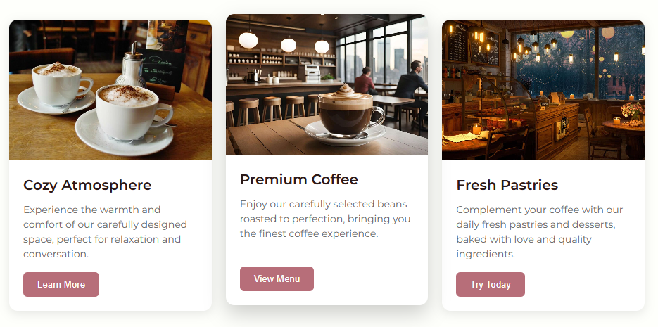

# Part 2: CSS Grid Implementation

## Task 3: Page Layout with Grid Areas

Objective: Implement a comprehensive grid-based layout system for the entire website structure.

1. Body Grid Setup:

css

body {

min-height: 100vh; display: grid;

grid-template-rows: auto 1fr auto;

grid-template-areas: "header"

"main" "footer";

}

1. Grid Area Assignments:

css

.header { grid-area: header; }

.main { grid-area: main; }

.footer { grid-area: footer; }

1. Sidebar Layout Option:

css

.grid-layout { display: grid;

grid-template-columns: 250px 1fr; grid-template-areas:

"sidebar content";

gap: 20px;

}

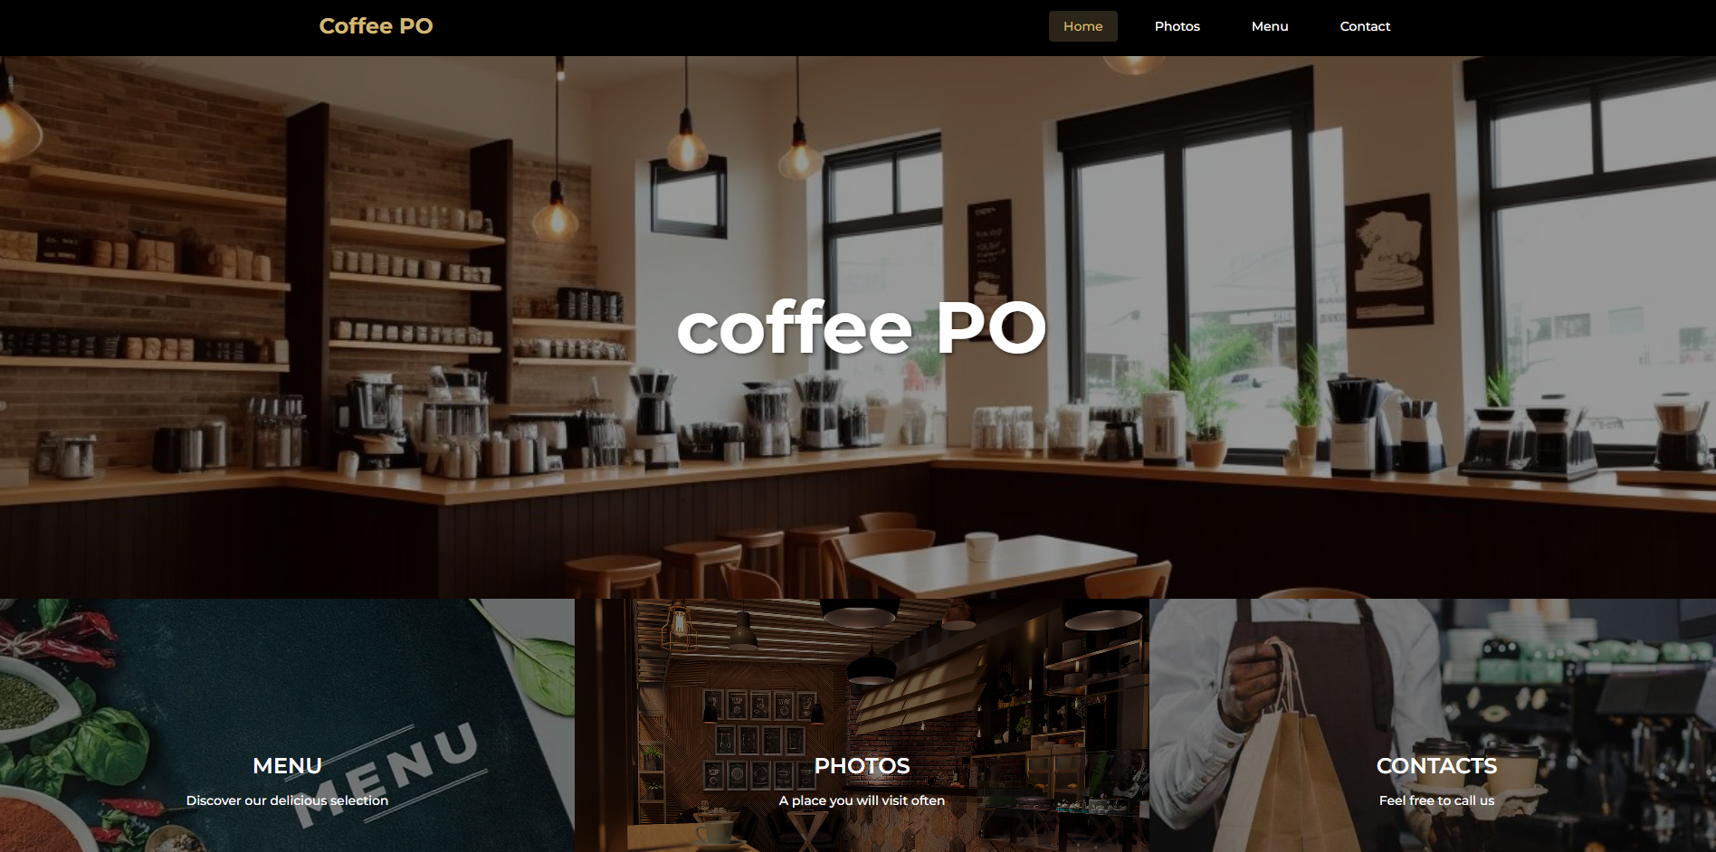 Изображение выглядит как текст, снимок экрана, Веб-сайт, веб-страница

Содержимое, созданное искусственным интеллектом, может быть неверным.

## Task 4: Image Gallery with CSS Grid

Objective: Create a responsive image gallery using CSS Grid with hover effects.

1. Gallery HTML Structure:

html

<div class="img-box">

<div class="imag-bord">

<img src="img/1.jpeg" alt="Coffee Shop Photo 1" />

<p>Cozy Atmosphere - Perfect for reading and relaxing</p>

</div>

*<!-- 8+ more images -->*

</div>

1. CSS Grid Gallery:

css

.img-box {

display: grid;

grid-template-columns: repeat(auto-fit, minmax(280px, 1fr)); gap: 25px;

max-width: 1200px; margin: 0 auto;

}

1. Hover Caption Effects:

Изображение выглядит как посуда, кофейная чашка, стол, соусник

Содержимое, созданное искусственным интеллектом, может быть неверным.

css

.imag-bord p {

position: absolute; bottom: 0;

transform: translateY(100%);

transition: transform 0.3s ease;

}

.imag-bord:hover p {

transform: translateY(0);

}

# Part 3: Combined Flexbox & Grid Results

## Integration Summary

|  |  |  |
| --- | --- | --- |
| **Component** | **Technology Used** | **Purpose** |
| Header Navigation | Flexbox | Logo and menu alignment |
| Page Layout | CSS Grid | Overall page structure |
| Card Components | Flexbox | Equal height card layouts |
| Image Gallery | CSS Grid | Responsive image grid |
| Menu Items | Flexbox | Content alignment |
| Footer | Flexbox | Contact info layout |
|  |  |  |

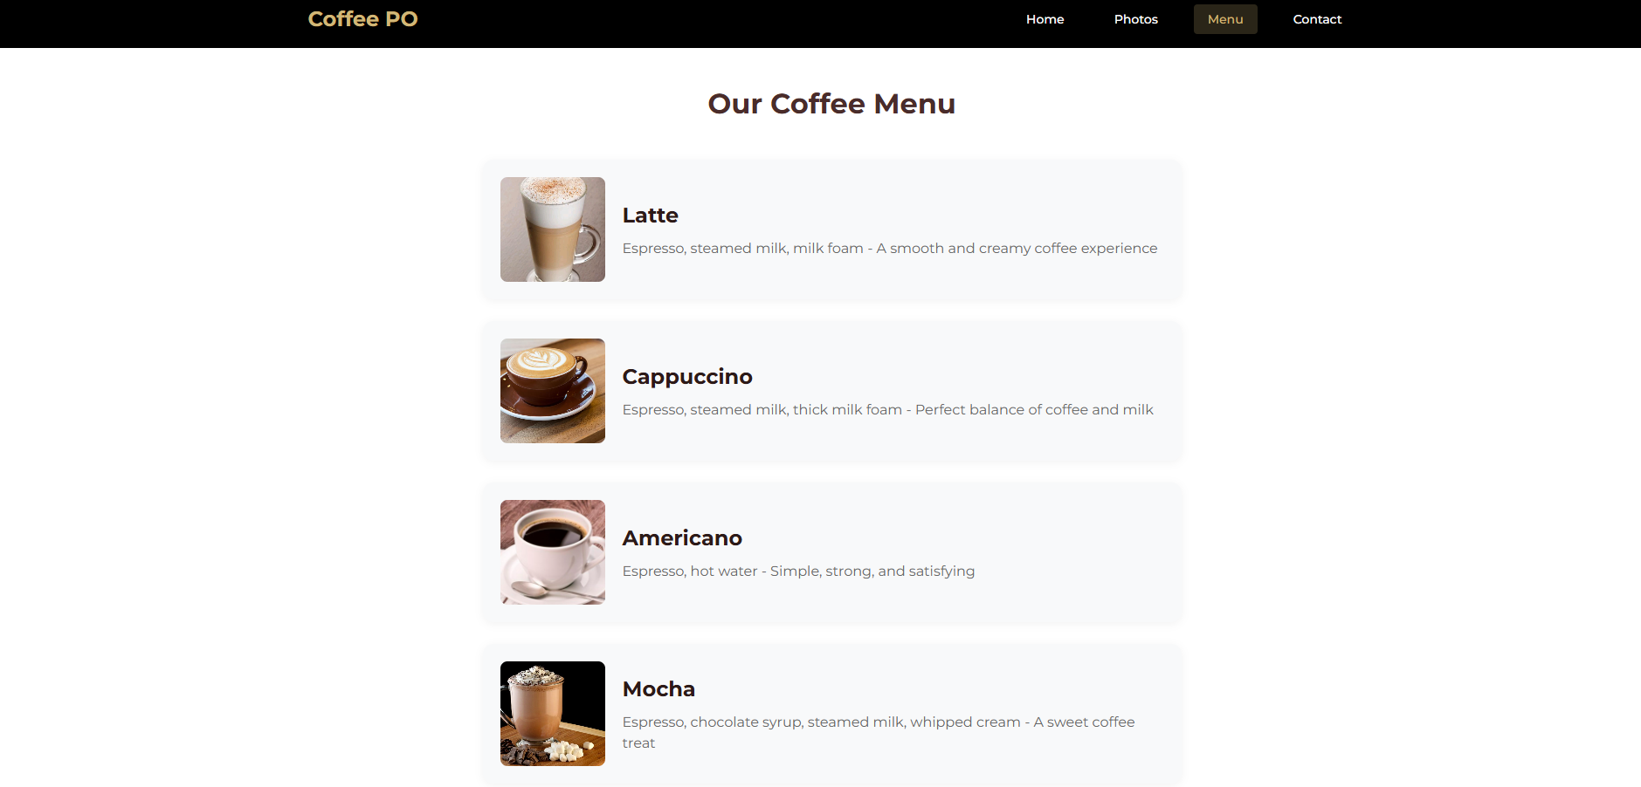

Изображение выглядит как текст, снимок экрана, программное обеспечение, Веб-сайт

Содержимое, созданное искусственным интеллектом, может быть неверным.

# Part 4: Responsive Design Implementation

## Mobile-First Approach

Media Query Implementation:

css

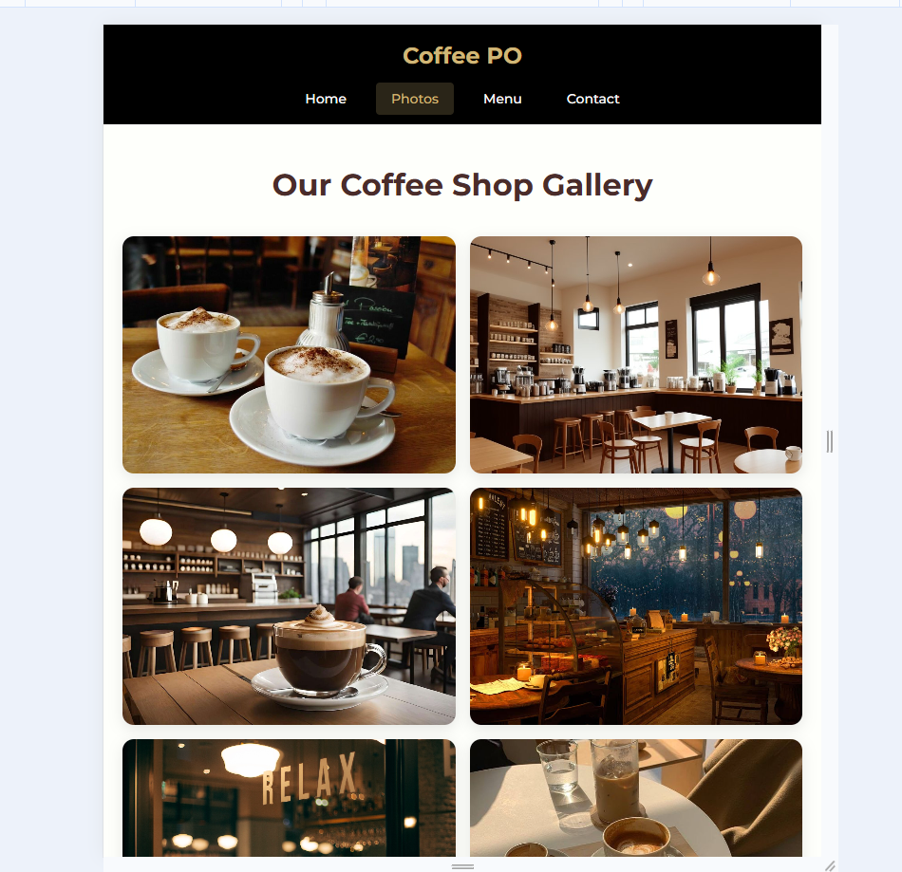

@media (max-width: 768px) {

.header-container {

flex-direction: column; gap: 15px;

}

.promo-grid {

flex-direction: column; height: auto;

}

.img-box {

grid-template-columns: repeat(auto-fit, minmax(250px, 1fr));

}

.card-container {

flex-direction: column; align-items: center;

}

}

# Deployment Information

Repository Details:

 GitHub Repository: <https://github.com/aaituu/BalgynWEB/web3/>

 Live Website URL: <aaituu.github.io/BalgynWEB/web3>

# Code Quality and Structure

## File Organization:

web3/

├── index.html

├── gallery.html

├── menu.html

├── contact.html

├── style.css

└── img/

├── 1.jpeg

├── 2.jpg

└── ...

CSS Structure:

1. General Styles - Reset and base styles
2. Header Styles - Flexbox navigation
3. Main Content - Grid layouts and components
4. Gallery Styles - Grid image gallery
5. Menu Styles - Flexbox menu items
6. Contact Styles - Form layout
7. Footer Styles - Footer layout
8. Responsive Styles - Media queries

# Conclusion

In completing this assignment, I have successfully mastered modern CSS layout techniques.

Specifically, I learned to expertly utilize Flexbox for efficient one-dimensional alignment and spacing. Effectively apply CSS Grid to build complex, two-dimensional page structures. Develop truly responsive and adaptive designs without relying on external frameworks.

This experience has equipped me with the skills to write clean, scalable, and professional CSS for contemporary web interfaces.

Report Prepared By: Team Coffee PO

Submission Date: 26.09.2025